Michael Villavicencio

ET721

**Project 1 - Basics of Version Control**

**Deliverables for Task 0 –**

Setup your local environment

Both Student A and B each are expected to deliver all of the following:

o Individually screenshots of:

* Successfully installed git (git --version)

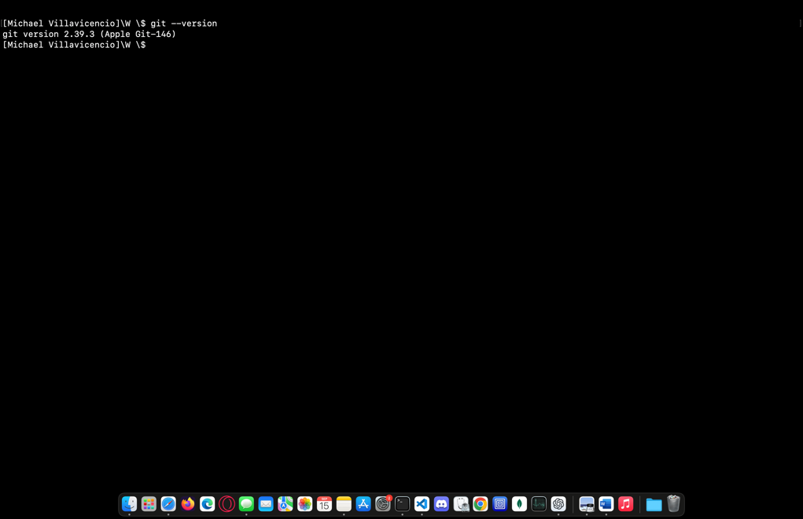

* Successfully setup SSH auth to communicate to GitHub (ssh -T [git@github.com](mailto:git@github.com))

* Successfully cloned repository (git clone)

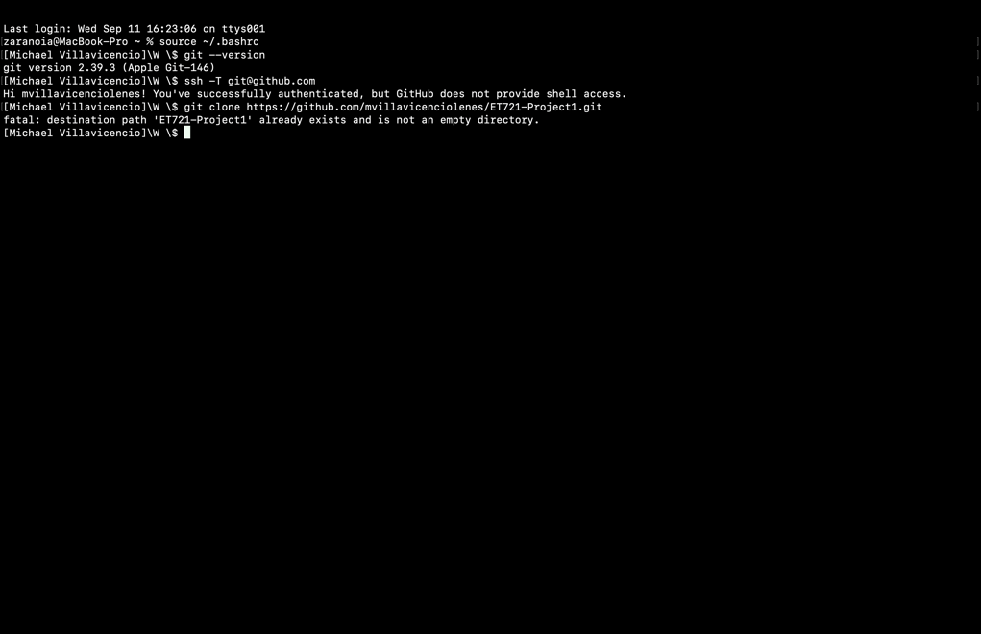

* Exceeds requirements: successful config setup (git config --list)

* Links to their GitHub account

<https://github.com/mvillavicenciolenes>

o Two sentences in responses to each question below:

1. What is GitHub and why did you have to create a repository there?

GitHub is an online platform where developers can store their code, track changes, and collaborate with others. I created a repository there to keep my project organized, share it with Ragvir, and make it easy to manage updates and changes

1. Why did you have to set up SSH and connect the public key to your account?

Setting up SSH with a public key makes it easier and safer to connect to GitHub from my computer without having to enter a password each time. It ensures that all the changes I push or pull are secure and properly authenticated.

**Step 1 - Small change**

Start by making a small change in the repository.

Student A:

1. Edit the README.md file by putting your name at the end of the file.

2. Commit the change using git add README.md to stage the changes and then commit with git commit -m

"Updated README with my name Student A".

3. Push the change to GitHub using git push to share the version with Student B

**Step 2 - Bug fixes**

There are two bugs present in the code. Each student needs to find one bug, commit the solution, and push it to the remote repository.

You can find the bugs by running the application a couple of times:

Take a screenshot of the terminal showing git log with commits that solve those bugs

Provide a link to the GitHub commit history for your repository showing the commits present

**Deliverables for Task 1 - Initial Commit and Push**

Both Student A and B are expected to deliver each of the following separately:

o Screenshots of:

1. The local output of the command git log showing the commits made

2. A GitHub remote repository history showing the commit pushed to remote repository

3. Screenshot of the bug and your solution

o Two sentences